Working with Documents – Exercise 3!
Welcome to your last document based assignment. In this document you will learn about using pictures and tables.
Here is a checklist of what you will learn today. Each one that you master, add an X in the () like this (X).
Insert a SMALL picture () | Picture with grey border () | Picture Caption () | Citation () | Picture Alignment ()
Tables () | Table Borders () | Merging Cells () | Split Cells

Getting Started
Create a new document called Exercise 3.

Picture and Border
As you can see, inserting pictures helps. First, choose a small picture of your favourite food from the internet and save it to your computer. Don’t close the browser!
To insert a picture, choose the 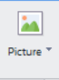. Choose the file and then insert it.
Once you added the image, try growing and shrinking it by clicking on it once and dragging the white squares on the side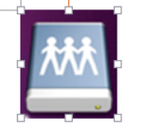.
When you click on the image notice that a new tab appears called Picture Tools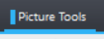. With your picture, click on outline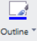 to give your picture a border. You can change the border by clicking on the arrow. Choose your favourite colour as the border.

Picture Caption
A caption is a little text that tells the reader about the picture. Right click the picture and select Caption…
You will see this screen:
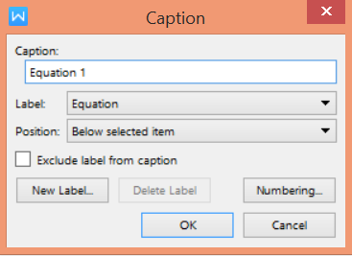
Click on Equation and change it to Figure.
In the Caption box, type your name, and why you like this food, and click OK.
For example:
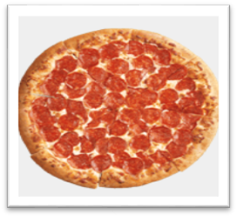
Figure 1 Mr. Lee likes pizza because it is round.

Citation
Citation means telling the reader where you get your information.
Copy and paste where you got your photo, and write what the picture is about/what you can see in the picture.
For example:
Pizza - https://www.pizzahut.com/assets/w/tile/thor/Pepperoni_Lovers_Pizza.png


Picture Alignment
IMAGE PLACEMENT means where you put your picture. Click on the Wrap Text and choose Behind Text. This will the picture be placed behind all your words. There are other ways to change how your picture is placed in the document, and you should try them out.
Move this picture to the top left corner of the page.

Tables
A TABLE is a way to show information in an organized way. You can create a table by clicking on the Insert tab, and then clicking on the Table button. Choose to create a 2 x 2 table, and fill it with 4 places you want to go one day.

Table Borders
Tables can also be made to look professional. One way we can do this is to change the way the lines (borders) look.
Click on the table and click on the tab. Then click on the , which will open up a window:
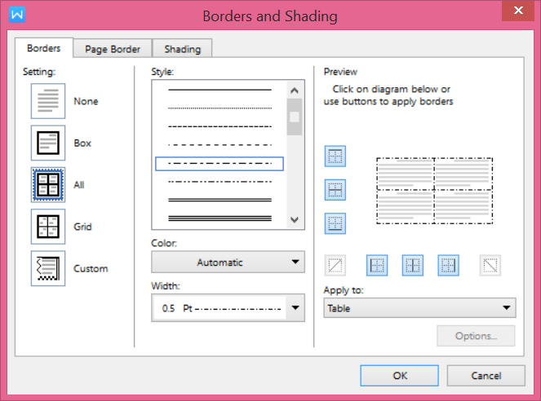
Change the Setting to Box, Style to a dotted line, and Width to 4.5, and click OK.
You can do this to the entire table, or just a few cells. Select the two left cells, and go back to Borders and Shading. This time, change it to a different Style, Color, and Width.

Merge and Delete Cells
Another way is to merge cells. Choose the top two cells and click on the  tab. Then click on Merge Cells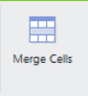. Now the two cells become one.
The opposite is to Split cells, to divide a cell into more cells. Choose the bottom right cell and click on the 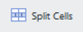 button. You can choose how many rows (up and down levels) and columns (left and right levels) to split it to. Choose to split the cell into 2 columns.
Put one of the words in the merged cell to the new cell.
Finally, if we want to make our boxes look BALANCED, or equal, choose the bottom 3 cells. Then click on the 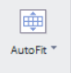 and choose Distribute Columns Evenly.

